INFORMACIÓN BÁSICA
NOMBRE DE LA PRÁCTICA:  Morphological operations | PRÁCTICA No.:  3
ASIGNATURA:
Digital image processing
TEMA DE LA PRÁCTICA:
Morphological operations

LABORATORIO A UTILIZAR:

Laboratorio de informática
CONTENIDO DE LA GUÍA
(Para elaborar por el Docente)
OBJECTIVES.

- To apply techniques of dilatation, open, closure, fill and aperture.
- To analyze and compare the effects of different types morphological operations.
- To perform and design segmentation techniques as otsu and water shed.

INTRODUCTION.
Binary images may contain numerous imperfections. In particular, the binary regions produced by simple thresholding are distorted by noise and texture. Morphological image processing pursues the goals of removing these imperfections by accounting for the form and structure of the image. These techniques can be extended to grayscale images.

Basic concepts
Morphological image processing is a collection of non-linear operations related to the shape or morphology of features in an image. According to Wikipedia, morphological operations rely only on the relative ordering of pixel values, not on their numerical values, and therefore are especially suited to the processing of binary images. Morphological operations can also be applied to greyscale images such that their light transfer functions are unknown and therefore their absolute pixel values are of no or minor interest.
Morphological techniques probe an image with a small shape or template called a structuring element. The structuring element is positioned at all possible locations in the image and it is compared with the corresponding neighbourhood of pixels. Some operations test whether the element "fits" within the neighbourhood, while others test whether it "hits" or intersects the neighbourhood:
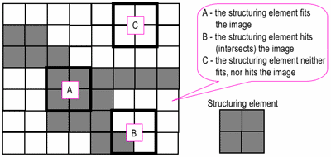
Probing of an image with a structuring element
(white and grey pixels have zero and non-zero values, respectively).
A morphological operation on a binary image creates a new binary image in which the pixel has a non-zero value only if the test is successful at that location in the input image.
The structuring element is a small binary image, i.e. a small matrix of pixels, each with a value of zero or one:
- The matrix dimensions specify the size of the structuring element.
- The pattern of ones and zeros specifies the shape of the structuring element.
- An origin of the structuring element is usually one of its pixels, although generally the origin can be outside the structuring element.
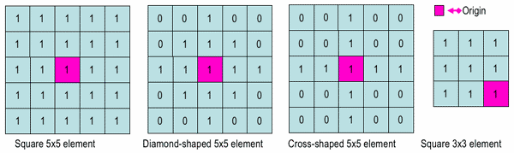
Examples of simple structuring elements.
A common practice is to have odd dimensions of the structuring matrix and the origin defined as the centre of the matrix. Stucturing elements play in moprphological image processing the same role as convolution kernels in linear image filtering.
When a structuring element is placed in a binary image, each of its pixels is associated with the corresponding pixel of the neighbourhood under the structuring element. The structuring element is said to fitthe image if, for each of its pixels set to 1, the corresponding image pixel is also 1. Similarly, a structuring element is said to hit, or intersect, an image if, at least for one of its pixels set to 1 the corresponding image pixel is also 1.
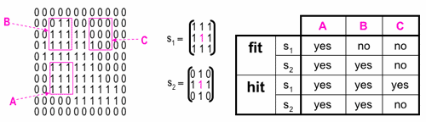
Fitting and hitting of a binary image with structuring elements s1 and s2.
Zero-valued pixels of the structuring element are ignored, i.e. indicate points where the corresponding image value is irrelevant.

Fundamental operations
More formal descriptions and examples of how basic morphological operations work are given in the Hypermedia Image Processing Reference (HIPR) developed by Dr. R. Fisher et al. at the Department of Artificial Intelligence in the University of Edinburgh, Scotland, UK.

Erosion and dilation
The erosion of a binary image f by a structuring element s (denoted f s) produces a new binary image g = f s with ones in all locations (x,y) of a structuring element's origin at which that structuring element s fits the input image f, i.e. g(x,y) = 1 is s fits f and 0 otherwise, repeating for all pixel coordinates (x,y).
Greyscale imageBinary image by thresholdingErosion: a 2×2 square structuring elementhttp://documents.wolfram.com/applications/digitalimage/UsersGuide/Morphology/ImageProcessing6.3.html
Erosion with small (e.g. 2×2 - 5×5) square structuring elements shrinks an image by stripping away a layer of pixels from both the inner and outer boundaries of regions. The holes and gaps between different regions become larger, and small details are eliminated:
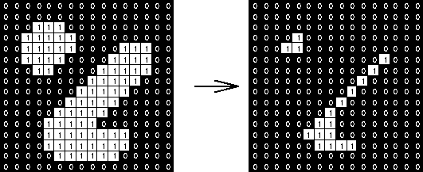
Erosion: a 3×3 square structuring element
(www.cs.princeton.edu/~pshilane/class/mosaic/).
Larger structuring elements have a more pronounced effect, the result of erosion with a large structuring element being similar to the result obtained by iterated erosion using a smaller structuring element of the same shape. If s1 and s2 are a pair of structuring elements identical in shape, with s2 twice the size of s1, then
f s2 ≈ (f s1) s1.
Erosion removes small-scale details from a binary image but simultaneously reduces the size of regions of interest, too. By subtracting the eroded image from the original image, boundaries of each region can be found: b = f − (f s ) where f is an image of the regions, s is a 3×3 structuring element, and b is an image of the region boundaries.
The dilation of an image f by a structuring element s (denoted f s) produces a new binary image g = f s with ones in all locations (x,y) of a structuring element's orogin at which that structuring element s hits the the input image f, i.e. g(x,y) = 1 if s hits f and 0 otherwise, repeating for all pixel coordinates (x,y). Dilation has the opposite effect to erosion -- it adds a layer of pixels to both the inner and outer boundaries of regions.
Binary imageDilation: a 2×2 square structuring elementhttp://documents.wolfram.com/applications/digitalimage/UsersGuide/Morphology/ImageProcessing6.3.html
The holes enclosed by a single region and gaps between different regions become smaller, and small intrusions into boundaries of a region are filled in:
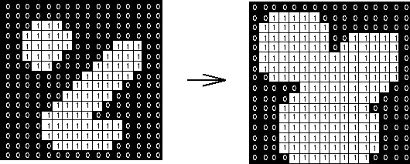
Dilation: a 3×3 square structuring element
(www.cs.princeton.edu/~pshilane/class/mosaic/).
Results of dilation or erosion are influenced both by the size and shape of a structuring element. Dilation and erosion are dual operations in that they have opposite effects. Let f c denote the complement of an image f, i.e., the image produced by replacing 1 with 0 and vice versa. Formally, the duality is written as
f s = f c srot
where srot is the structuring element s rotated by 180. If a structuring element is symmetrical with respect to rotation, then srot does not differ from s. If a binary image is considered to be a collection of connected regions of pixels set to 1 on a background of pixels set to 0, then erosion is the fitting of a structuring element to these regions and dilation is the fitting of a structuring element (rotated if necessary) into the background, followed by inversion of the result.

Compound operations
Many morphological operations are represented as combinations of erosion, dilation, and simple set-theoretic operations such as the complement of a binary image:
f c(x,y) = 1 if f(x,y) = 0, and f c(x,y) = 0 if f(x,y) = 1,
the intersection h = f ∩ g of two binary images f and g:
h(x,y) = 1 if f(x,y) = 1 and g(x,y) = 1, and h(x,y) = 0 otherwise,
and the union h = f ∪ g of two binary images f and g:
h(x,y) = 1 if f(x,y) = 1 or g(x,y) = 1, and h(x,y) = 0 otherwise:

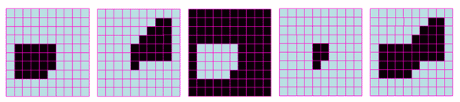
Set operations on binary images: from left to right: a binary image f,
a binary image g, the complement f c of f, the intersection f ∩ g, and the union f ∪ g.
The opening of an image f by a structuring element s (denoted by f s) is an erosion followed by a dilation:
f s = ( f s) s

Binary imageOpening: a 2×2 square structuring elementhttp://documents.wolfram.com/applications/digitalimage/UsersGuide/Morphology/ImageProcessing6.3.html
Opening is so called because it can open up a gap between objects connected by a thin bridge of pixels. Any regions that have survived the erosion are restored to their original size by the dilation:
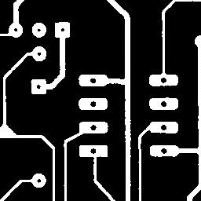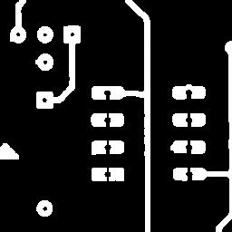Binary image ff s (5×5 square)f s (9×9 square)Results of opening with a square structuring element (www.mmorph.com/html/morph/mmopen.html/).
Opening is an idempotent operation: once an image has been opened, subsequent openings with the same structuring element have no further effect on that image:
(f s) s) = f s.
The closing of an image f by a structuring element s (denoted by f • s) is a dilation followed by an erosion:
f • s = ( f srot) srot

Binary imageClosing: a 2×2 square structuring elementhttp://documents.wolfram.com/applications/digitalimage/UsersGuide/Morphology/ImageProcessing6.3.html
In this case, the dilation and erosion should be performed with a rotated by 180 structuring element. Typically, the latter is symmetrical, so that the rotated and initial versions of it do not differ.

Closing with a 3×3 square structuring element
(www.cs.princeton.edu/~pshilane/class/mosaic/).
Closing is so called because it can fill holes in the regions while keeping the initial region sizes. Like opening, closing is idempotent: (f • s) • s = f • s, and it is dual operation of opening (just as opening is the dual operation of closing):
f • s = (f c s)c; f s = (f c • s)c.
In other words, closing (opening) of a binary image can be performed by taking the complement of that image, opening (closing) with the structuring element, and taking the complement of the result.
The hit and miss transform (see also HIPS2 web page) allows to derive information on how objects in a binary image are related to their surroundings. The operation requires a matched pair of structuring elements, {s1, s2}, that probe the inside and outside, respectively, of objects in the image:
f {s1, s2} = (f s1) ∩ (f c s2).

Binary imageHit and miss transform:
an elongated 2×5 structuring elementhttp://documents.wolfram.com/applications/digitalimage/UsersGuide/Morphology/ImageProcessing6.3.html
A pixel belonging to an object is preserved by the hit and miss transform if and only if s1 translated to that pixel fits inside the object AND s2 translated to that pixel fits outside the object. It is assumed that s1 and s2 do not intersect, otherwise it would be impossible for both fits to occur simultaneously.
It is easier to describe it by considering s1 and s2 as a single structuring element with 1s for pixels of s1 and 0s for pixels of s2; in this case the hit-and-miss transform assigns 1 to an output pixel only if the object (with the value of 1) and background (with the value of 0) pixels in the structuring element exactly match object (1) and background (0) pixels in the input image. Oterwise that pixel is set to the background value (0).
The hit and miss transform can be used for detecting specific shapes (spatial arrangements of object and background pixel values) if the two structuring elements present the desired shape, as well as for thinning or thickening of object linear elements.
Morphological filtering
of a binary image is conducted by considering compound operations like opening and closing as filters. They may act as filters of shape. For example, opening with a disc structuring element smooths corners from the inside, and closing with a disc smooths corners from the outside. But also these operations can filter out from an image any details that are smaller in size than the structuring element, e.g. opening is filtering the binary image at a scale defined by the size of the structuring element. Only those portions of the image that fit the structuring element are passed by the filter; smaller structures are blocked and excluded from the output image. The size of the structuring element is most important to eliminate noisy details but not to damage objects of interest.
Incomputer vision, image segmentation is the process of partitioning a digital image into multiple segments sets of pixels, also known as super-pixels. The goal of segmentation is to simplify and/or change the representation of an image into something that is more meaningful and easier to analyze. Image segmentation is typically used to locate objects and boundaries (lines, curves, etc.) in images. More precisely, image segmentation is the process of assigning a label to every pixel in an image such that pixels with the same label share certain characteristics.
The result of image segmentation is a set of segments that collectively cover the entire image, or a set of contour extracted from the image. Each of the pixels in a region are similar with respect to some characteristic or computed property, such as color, intensity, or texture. Adjacent regions are significantly different with respect to the same characteristic(s). When applied to a stack of images, typical in medical imaging the resulting contours after image segmentation can be used to create 3D reconstructions with the help of interpolation algorithms like Marching cubes.

PREVIOUS KNOWLEDGE

- Read about 2D boundary.
- Read about 2D morphologic operations.
- Read about segmentation watershed and otsu.

METHODOLOGY

1. Load the image ‘hestain.png’ from the sample images. Correct it ,enhace the gray level and contrast and remove noise if it corresponds, do the following exercises.

MATERIALS AND EQUIPMENT

Materials | Reactivos | Materiales Estudiante
Matlab (image processing toolbox)

PRECAUTIONS AND MATERIAL MANAGEMENT.

- Please take care of the computer assigned to you.
- Please do not enter food an liquids.
- Please do not enter your bagpack.

Exercises
With your own created functions:
- Binarize the image with the OTSU methoda and save the result.
- Binarize the image with the watershed method and save the result.
- Implement an automatic Labeling of each object from the resulting images depending on 8n connectionimage .
- From the resulting apply an opening operation and multiply point to point with the original image.
- apply a close operation and multiply point to point with the original image.

- Apply a dilate operation and multiply point to point with the original image.

- Apply an erosion opertaion and multiply point to point with the original image.

BIBLIOGRAFÍA RECOMENDADA.

[1] Digital Image Processing,
Gonzales, R.C., Woods, R.E
2ed, Prentice Hall, 2002

ELABORÓ  (Personas que elaboraron la guía) | REVISÓ  (Director de Programa o Área) | APROBÓ  (Laboratorios)
Firma Jorge Andres Alvarez Triana  Nombre :  Fecha:8/09/2016 | Firma  Nombre : Diana Paola Ovies Bernal  Fecha: | Firma  Nombre :  Fecha:

INFORME DE LABORATORIO
(Para elaborar por el Estudiante)
ESTUDIANTES: | GRUPO:
ESTUDIANTES: | NOTA:

CARRERA:

Formule tres objetivos que desee cumplir con la Práctica de Laboratorio
El estudiante formulará desde su conocimiento los objetivos para la realización de la práctica

Elabore un Mapa conceptual del tema a tratar en la Práctica de Laboratorio.

RESULTADOS
Incluir tablas, diagramas en la que los estudiantes puedan ir consignando los datos y observaciones obtenidos en la práctica

CAUSAS DE ERROR Y ACCIONES PARA OBTENER MEJORES RESULTADOS:

El estudiante formulara las posibles causas de error comparando sus resultados experimentales con los teóricos

CONCLUSIONES

El estudiante realizara una serie enunciados que respondan a los objetivos que el mismo formuló, basados en el desarrollo de la práctica.
QUESTIONARY

- Justify the algorithm used to rotate the matrix image.
- Justify the algorithm to apply bitslicing.
- Justify the algorithm to reduce the spatial resolution.

APLICACIÓN PROFESIONAL DE LA PRÁCTICA REALIZADA

BIBLIOGRAFIA UTILIZADA
[1] Digital Image Processing,
Gonzales, R.C., Woods, R.E
2ed, Prentice Hall, 2002

